PIPS Report Standard Work Instructions
Last Updated: February 2017 Owners: Will Huen, Troy Wiliams Leslie Safier, Jenny Chacon
Version: 5 Performed By: Departmental Leaders
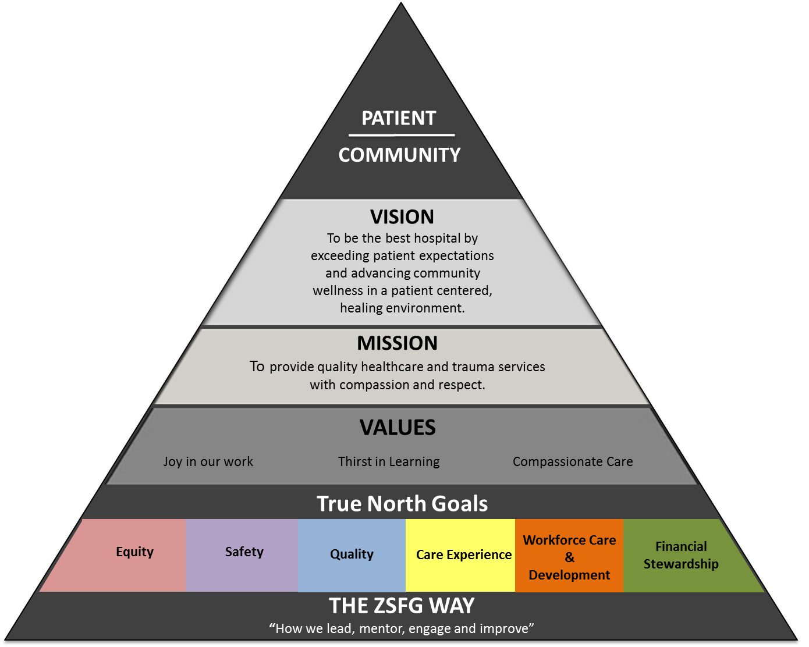
Purpose:
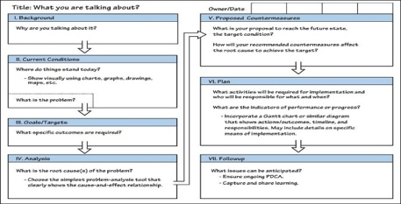
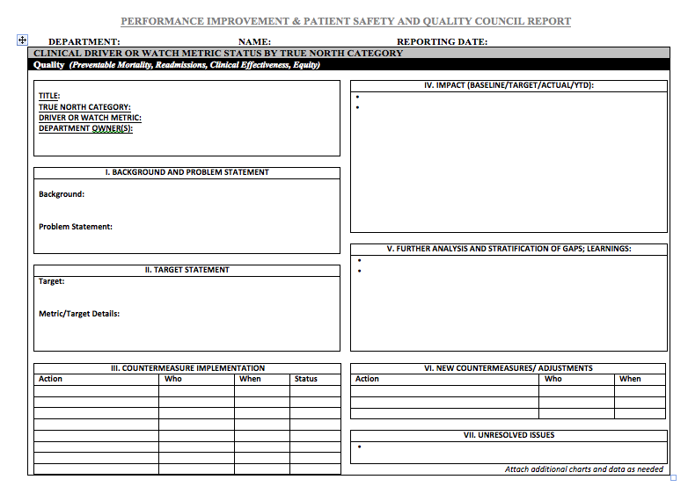
A3

A3 Status Report

- PIPS is an Interdisciplinary and Executive Medical Staff Committee, which in addition to regulatory requirements, serves the purpose of:
  - Communication – Learn the status of problem solving on drivers
  - Alignment – Identify common goals, challenges, partners
  - Accountability – Ensure all levels of organization drive true north

- The PIPS Report Template serves as a written document to:
  - Exec Summary: Highlight Achievements and Barriers
  - Scorecard: Summarize Drivers/Watch and PI Plan of New Drivers
  - Share our best problem solving aligned with True North

- Relevant changes include:
  - Integration of Exec Committee and Non-Clinical Services
  - Evolution of True North and Equity Category
  - PIPS Report Executive Summary, Scorecard and PI Plan
.

3. We improve continuously by focusing on performance gaps aligned with True North
- The sections of the report are structured as PDSA

2. We learn by sharing our problem solving and inviting questions
- Template highlights critical details of process improvement, ideally suited as a status report for thorough problem solving (A3 thinking)

1. We select measurable gaps and targets to improve (Drivers) that will impact system-wide goals (True North metrics)

Executive Summary

Purpose: The Executive Summary provides a high level summary of your complete report, which will be available for review ahead of time by reviewers, and displayed during discussion of your department’s efforts.
 | Major Step | Details | Diagram, Work Flow, Picture, Time Grid
1. | Header  This report will be displayed during your brief verbal presentation of:  - Introductions  - one achievement  - one barrier, and  - invitation of questions. | Department: Your reporting dept  Name: Individual names of your PI team members that own this report  Executive: If different from above, this is your Executive Member or Chief of Service.  Date: when reported to PIPS | Department: Medicine  Name: William Huen  Executive: Neil Powe  Date: June 2017
2. | Achievements  Summarize specific progress or achievements in your improvement efforts | We recommend no more than three specific achievements.  Note: We will invite you to share one achievement at PIPS. | Example:  Achievements - 90% outpatient turnaround times <30 minutes - 80% of inpatient discharge medication are delivered <120 minutes
3. | Challenges/Barriers | We recommend no more than three specific barriers or achievements. Ideally, these are unresolved challenges that may be cleared if escalated to PIPS.  Note: We will invite you to share one barrier at PIPS. | Example:  Challenges/ Barriers - We continue to receive discharge prescriptions with a high (38%) defect rate, which increases total processing time by average of 28 minutes each
4. | Staffing Adequacy  This question addresses a regulatory standard | Were any negative results or trends for the measures reported directly related to adequacy of staffing? Yes No  If yes, document specific measure impacted, how related to staffing adequacy, and any countermeasures implemented: | Examples:  Staffing Adequacy Were any negative results or trends for the measures reported directly related to adequacy of staffing? Yes No If yes, document specific measure impacted, how related to staffing adequacy, and any countermeasures implemented:

Executive Scorecard of Departmental Metrics and Proposed Performance Improvement Plan

Purpose: The Executive Scorecard and PI Plan provides a high level and visual summary of your complete report and PI Plan, which will be available for review ahead of time by reviewers, and displayed during discussion of your department’s efforts.

 | Major Step | Details | Diagram, Work Flow, Picture, Time Grid
1. | Drivers vs Watch Metrics  The report is stratified into Drivers above and and Watch Metrics below  The subsequent A3-SR template will be reserved to share your effort on this year’s drivers, or analysis of Watch metrics that are off target.  Watch metrics that are on-target will not need further elaboration than the scorecard | Driver or Watch Metric:  - Driver Metric: A target or goal that the department leadership team is actively working on to improve the performance of the department.  - Watch Metric: A target or goal that the unit is watching over time, but not actively working on to improve performance.  - Not all fields of the report will be relevant for watch metrics.
2. | True North Category  For each metric, indicate the primary alignment with True North | True North – defined as systemwide goals with metrics to measure and guide our collective improvement. Indicate the category most well aligned with project: | True North Category Measure Name Owner Measure Units Baseline FYTD (15-16)  Quality 30-Day Readmissions Thomas, L % 12.5%  True North Category Examples:  - Quality  - Safety  - Care Experience  - Developing People  - Financial Stewardship  - Equity  Measure Name Examples:  - 30-Day Readmission Rate  - Third Next Available Appointment  - Mortality Rate  Measure Units Examples: %, #, Days, Minutes, $, Injuries/1,000 pt days
3. | Measure Name  Please specify tbe name of the performance metric succinctly | Avoid unclear or unknown abbreviations
4. | Owner  Indicate the staff or faculty member owner | Specific name of the individual “owner” who reviews this metric
5. | Measure Units | Indicate the type of metrics units
6. | Baseline FYTD | Indicate the previous baseline.  Ideally, calculate the performance for the entire fiscal year to date, but indicate if the baseline is from a different time period (e.g. MTD, single measure)
7. | Current FYTD | Actual Performance: Indicate current performance measurement [11.3%]  Actual Performance Color: Change Cell Shading/Fill in table to  - Green: If ON Target  - Red: If OFF Target  Desired Direction: Indicate if the desired direction of the metric is “Up” or “Down”  12 M target: Indicate what your current target is for this time period. For Watch metrics, indicate what your expected performance is. | CURRENT FYTD (16-17)  Actual Performance; Color:On/Off- Target Desired Direction = (Up/Down) 12M Target  11.3% Down 11.4%  Explained: Our actual performance of 11.3% is On-Target, with our desired direction “Down” and our Target of 11.4%.
8. | Proposed PI Plan  Integrated into the scorecard of past and current metrics, these two additional columns are intended to indicate your proposed PI metrics for the coming year.  Add new rows for new metrics that were not Drivers for the past year | Driver/Watch: Indicate whether specific metrics are going to be Drivers or Watch Metrics for the coming year.  - Drivers, may include  - Adjusted drivers from previous years  - Previous watch metrics that are in the red  - New metrics with no previous targets  - Watch metrics, may include:  - Adjusted or previous watch metrics  - Previous driver metrics that continue in the green  - New watch metrics  New 12 Month Target: Indicate the expected or desired performance for the coming year. | CURRENT FYTD (16-17) Proposed PI Plan  Actual Performance; Color:On/Off- Target Desired Direction = (Up/Down) 12M Target Driver/Watch New 12M Target  11.3% Down 11.4% Driver 10%  Explained: Given successful achievement of performance, this metric will continue as a Driver, but with a new lower target of 10% for the coming year.
9. | Continue to add rows for each Driver | Overall goal is to create a single visual representation of your past, current and future performance goals  All Drivers are reported with detailed description/discussion in the A3-SR Template
10. | Note about Watch Metrics | For watch metrics that are on target, this single page scorecard may be all of the information you will share with PIPS.  If the current performance of a Watch Metric is in the Red, you will need to consider doing further analysis, stratification and PI planning using an A3-SR.

A3-SR PIPS Reporting Template

Purpose: To report our implementation of our best problem solving using a standardized problem solving language and approach, the A3-Status Report serves as a follow-up document to an initial problem solving plan and supports ongoing Plan-Do-Study-Adjust.

In contrast to an A3 Planning Document, the A3-Status Report presents thinking after A3 implementation, including previous background, problems and targets from the initial A3, but also updates the countermeasures implemented, the impact of these countermeasures, and further study and adjustments.

 | Major Step | Details | Diagram, Work Flow, Picture, Time Grid
A | Select departmental performance or performance improvement  The report will be comprised of updates on one or more improvement metrics.  Use one template page per improvement project, which may have one or more associated metrics.  Additional data, analysis or explanations can be attached in additional pages. | Criteria may include:  Performance Gaps: Select topics where you are not performing well, and improvement would be meaningful to your department  Alignment with True North: Select topics aligned with True North (see more about True North below)  Possible criteria for selecting what to report:  - Department’s interest, bandwidth and capacity for improvement  - Prioritizing a few well-done projects as opposed to attempting to improve everything in all categories.  - Topics you have identified through Performance Improvement Plans, A3s, past reports, department meetings, or meetings with hospital leadership.  - New internal or external standards
1 | Title Box  In the first box, describe the Title, True North Category, whether the metric is a Driver or Watch metric, and who owns this metric in your department. | True North – defined as systemwide goals with metrics to measure and guide our collective improvement. Indicate the category most well aligned with project:  - Quality  - Reducing Preventable Mortality  - Reducing Readmissions  - Safety  - Prevent Patient Harm;  - Prevent Staff Harm  - Care Experience  - Improve Patient Experience;  - Improve Patient Flow or Access  - Developing People  - Developing Problem Solvers;  - Staff Satisfaction  - Financial Stewardship  - Meeting Budget Goals;  - Decrease Length of Stay  Driver or Watch Metric:  - Watch Metric: A target or goal that the unit is watching over time, but not actively working on to improve performance.  - Not all fields of the report will be relevant for watch metrics.  - Driver Metric: A target or goal that the department leadership team is actively working on to improve the performance of the department. | Example:  Title: Reducing sepsis mortality  True North Category: Quality  Driver or Watch Metric: Driver Metric  Department Metric Owner(s): Antonio Gomez, Joe Clement
2 | Background/Current Condition and Problem Statement  Summarize the background and provide a Problem Statement for the metric. | Background: Include what the problem is and why the improvement is required now, or describe past efforts to solve the problem.  Current Condition: Describe current processes and results occurring now that require change  Problem Statement: The Problem statement includes exact timeframe and one or more measures of the baseline gap that is a problem for your patients or the organization. Not a statement of the root cause, or the lack of a specific project or solution.  May not apply if a Watch Metric | Background Example: “Sepsis is the leading cause of death in Department of Medicine patients (37% of all deaths).”  Current Condition: “80% of sepsis patients are admitted through the ED to Medicine, but we only complete 50% of bundle requirements.”  Problem Statement Example: “The sepsis mortality rate was 20% in 2010.”  Example of Problem Statements that could be better:  - “SFGH does not have a sepsis bundle and a sepsis team” (A solution in disguise rather than a problem)  - “Sepsis can lead to the dangerous failure of multiple organs due to infection.” (Lacks a measurable problem and time frame)
3. | Target Statement  Describe the target of your project, and how that target is defined, measured and compared. | Target: Specify a specific, measurable, achievable, relevant, 12-month target, ideally from an existing project plan (e.g. A3).  Metric/target details may include:  - Definition for your metrics, such as numerators, denominators, calculations  - Monitoring process  - Explanation for the target  - Existing benchmarks/standards  - Trigger for when a watch metric might become a driver metric. | Target Example: “Reduce the annual sepsis mortality rate from 20% in 2010 to 11% by December 2014.”  Metric/Target Details Example:  - Ongoing chart review of patients with severe sepsis or septic shock.  - Sepsis Bundle includes:  - Measure serum lactate  - Blood cultures pre-antibiotics  - Antibiotics < 3 hours (1 hr inpt)  - Fluid bolus of 30 ml/kg  - Stabilize MAP to >65  - Target defined by DSRIP goals
4. | Countermeasure Implementation Status  List of the actions planned and taken to improve this metric to date. | Countermeasures are actions, generally taken to offset specific threats or root causes/barriers.  Update the original action plan found in the related A3, if one exists. Include specific names of who is responsible, the planned implementation date, and when the action was completed.  If only a watch metric, explain process of reviewing data. | Example:  III. Countermeasure Implementation Status  Barrier/Cause Addressed Countermeasure Who Date/Status  Data Review and Ownership Sepsis Task Force review w/ 4 DOM faculty Jan 2016, monthly  Awareness of Errors M&M Case Reviews Task Force/Chief Feb 2016, monthly  Awareness and Reliance on Memory Dept dashboard, pocket cards Clement/Haber April 2016  Integration into academic curriculum MSIII curriculum, case review Jeevanjee May 2016  Variations in Care Ordered ICU CPOE Sepsis Order Set Clement/CPOE team Delayed

5. | Impact  Summarize the impact of the actions completed to achieve the original targets. | Provide graphs or other visual information to promote quick comprehension, with brief narrative to summarize takeaway points.  Be sure to include information about the baseline, the target, current performance, and YTD if possible.  Run charts (line charts) are useful to show how you have impacted progress across time. Each chart has baseline, target, actual performance, and year to date if applicable. Colors should be as follows:  - Baseline: Black dashed line  - Target: Green solid line  - Actual: Black solid line  - Year to date is optional: Blue  These could be taken directly off of a model cell scorecard, as available.  Histograms (bar charts) are useful for summarizing impact when comparing approaches, periods of time (i.e baseline vs year-to-date), or categories. | Example of a run chart:  Examples of Histogram (bar chart):
6 | Further analysis and stratification of gaps; Learnings  Especially if you have not achieved your target, analyze why not. Insert summary of relevant analysis, learnings and/or stratification | Stratification: In order to learn more about why you have not achieved your targets, divide your data into relevant groups (strata) based on key characteristics, such as:  - Who: which patients, staff or departments?  - Where: Unit, clinic, setting?  - What: machines, equipment, products  - How: defect types, cause  - When: time of day, day of week, step of process  Top Contributors: As you study your problem and “ask why 5 times” about why you continue to have performance gaps, quantify the top contributors or root causes to target for future countermeasures.
7 | New Countermeasures/  Adjustments  Explain next steps that you are planning, including changing between watch and driver metrics or resetting targets.  Especially if target has not been met, describe what will be done differently in the future. | Include:  - Action  - Who is responsible  - When this action is expected, ideally within next 90 days  These countermeasures should generally be linked to the barriers or root causes. Countermeasures may include:  - Process changes to remove underlying root causes  - A temporary fix until a better approach is found  - Elimination of preventable sources of variation  - Develop clearer ownership  - May be a PDSA or new project  - May be a combination of efforts  - Revision of targets and baselines | Examples:  VI. New Countermeasures/ Adjustments  Action Who When  Driver: 2016 Target to reduce mortality <9.5%. Task force Monthly  A3 Development for antibiotics within the ED Joe Clement Aug 2015  Level of Care for Bldg 25: Establishing ideal care pathways given new levels of care in Bldg 25. Joe Clement and Angonio Gomez Aug 2015
8 | Unresolved Issues | Describe ongoing issues that you have not been able to resolve despite implementation of your plan and discussion with leadership and stakeholders. Frequently these issues require escalation or that are outside of your department’s control, but efforts have been made to address or communicate beforehand.

Example: Template with Annotated Tips
Title:  True North Category: [Indicate which of the 5 True North categories]  Driver or Watch Metric: [Indicate if active driver or watch metric]  DEPARTMENT: [Indicate department or unit owners]  Department Owner(s): [Indicate departmental owners]  I. BACKGROUND/CURRENT CONDITION AND PROBLEM STATEMENT  Background/Current Condition:  - [Background summarizes the problem and why improvement is required now; past efforts]  - [Current Condition summarizes current processes and results]  Problem Statement:  - [Problem statement includes one or more measures of the baseline gap with an exact timeframe]  II. TARGET STATEMENT  Target:  - [Specify a specific, measurable, achievable, relevant, 12-month target, ideally from an existing A3]  Metric/Target Details:  - [May include operational definition for your metrics, how you calculated numerators, denominators, etc]  - [May include rationale for your target, consideration of benchmarks]  III. Countermeasure Implementation  Cause/Barrier Action Who When/Status  [why was this action needed?] [indicate which actions you have taken to improve] [Use names as possible] [Completion Date] | IV. Impact (Baseline/Target/Actual/YTD):  - [Summarize impact on performance related to your target and baseline]  - [Use run charts or other types of charts to make your data visual]  V. FURTHER Analysis and Stratification of Gaps; Learnings:  - [Especially if you have not achieved target, summarize further analysis, stratify data (e.g. unit, service, type), or identify top contributors/causes]  - [Use charts to make your analysis visual, such as a pareto chart]  VI. New Countermeasures/ Adjustments  Action Who When  [Describe what will be done differently now, targeting identified barriers or top contributors from further analysis]  [Describe how target will be continued, adjusted, broadened, moved to watch/driver]  VII. Unresolved Issues  - [List issues that are unresolved, including human resources, unbudgeted resources, project issues.]  Attach additional charts and data as needed

