**Student Placements at ZSFG - COVID-19 Additional Orientation**

**(Updated: 6.11.2020)**

In determining our ability to uphold our commitment to our academic partners while ensuring the health and safety of our patients, staff, and community during our ongoing response to COVID-19, ZSFG will be inviting nursing and allied health students* to return to our campus beginning Summer 2020. Though we cannot return to our historical capacity at this time, ZSFG will adopt a phased approach for accepting student placements. In our phase for the upcoming summer, placements will be provided on a case by case basis, and will be dependent on our ability to safely accommodate students, instructors, and faculty in our hospital while maintaining adherence to local, state, federal, and regulatory guidance on COVID-19.

As always, our affiliated schools and universities must comply with all DPH and ZSFG student placement procedures and onboarding requirements, including health history, screening, and vaccinations. SFDPH approved schools and universities must have an up to date Affiliation Agreement that covers health and safety requirements and liability. Given our current circumstances, there will be additional expectations:

* All schools with nursing and allied health students at ZSFG will need to submit a plan outlining their procedures for screening students, instructors, and faculty for illness as well as a summary of the procedures that will be implemented in the event that any of their staff, instructors, and student assigned to our campus test positive to COVID-19. ZSFG Preceptor/Department student coordinator will keep a copy of the signed Covid-19 training consent & the schools plan for COVID-19 positive student, instructor, and faculty along with the other ZSFG onboarding documentation
* Students, instructors, and faculty projected to be placed on our campus will be required to complete a COVID-19 orientation module.

**Students must read and agree to adhere to the COVID-19 orientation instructions on the following pages.**

**Badging:** student always agrees to wear their school photo ID badge visible on their upper body. If they do not have their school photo ID badge they must leave the campus to retrieve it.

**Entering the ZSFG campus:** students will follow the directions to be screened at the Staff/Employee screening entrance which is located in Building 25, main hospital lobby entrance door. This is the only entrance to gain access to ZSFG Building 5 or Building 25.

*allied health professionals defined by the Association of Allied Health Professionals as people who are “involved with the delivery of health or related services pertaining to the identification, evaluation and prevention of diseases and disorders.” This includes non-nursing and non-physician roles like sonographers, dietitians, medical technologists, occupational therapists, medical assistants, physical therapists and public health administers as well as many more. <http://www.asahp.org/what-is>

## PROTECT ME

**No matter where you are on the ZSFG campus, you need to where a face covering – there are no exceptions. We ask that students and instructors do not enter ZSFG campus if they are not feeling well.**



|  |  |
| --- | --- |
|   **Isolation Mask** | **★UDPATE:** Staff/students working in clinical areas (listed below) must wear isolation masks ***at all times***.  *Clinical Areas: Buildings 25, 5, 9, 4, 100 (Outpatient Dialysis Only), 80, 90, 10 (Billing Office Only), CHN (HR staff who meet with the public – new hires)* |
|   **Cloth Mask** | **★UDPATE:** Staff/students working in areas/departments other than the buildings outlined above can choose to wear cloth masks. If they enter a clinical area, they will be asked to remove their cloth mask and will be provided with an isolation mask. |

Non-hospital use respirators should not be worn at ZSFG as a part of universal masking. Please review the [Acceptable Face Covering flyer](https://mcusercontent.com/46b917758ba60c903849c6855/files/4f02b80d-98a9-40ae-abf6-5cd3e066159b/Acceptable_Face_Coverings_200520.pdf) (page 4) for more information.



## PROTECT ME

**★Where do students get screened on the ZSFG campus:**

Students will follow the directions to be screened at the Staff/Employee screening entrance that is located in Building 25, main entrance door.

* **This is the only entrance to gain access to ZSFG Building 5 or Building 25.**
* **Be prepared for a possible line up during peak times.**

**★ Screening Questions:** To ensure the safety of our staff, students, providers and patients, the screening symptoms list is aligned with the CDC COVID-19 symptom list. Additionally, the patient and visitor screening questions are also aligned.

* Loss of smell or taste
* Recent COVID-19+ test
* Exposure to someone with COVID-19
* Body Aches
* Chills
* Sore throat
* Night sweats
* Fever (Temp >37.8°C / 100.0°F)
* Shortness of breath
* Difficulty breathing
* Cough

Please support the screening team by answering all the questions. For expediated in-person screening, please complete the [ZSFG online screening](https://forms.office.com/Pages/ResponsePage.aspx?id=z8LVIj7OPUSaf9_MAjH3P-ZtKIz43ARNpRNHmU4C-qFUMFFZSzc0VklUTUg3Q1JQNE5TUzlEUkRGUy4u&qrcode=true) form. If using the online form, be prepared to show the screener the email received back on your phone. Wear the daily screening sticker on your school photo ID badge. It should be visible for all staff to see that you have completed the daily screening.

**★Reinforcing Good Practices:**

While waiting in line for screening please be respectful of others by remembering the following practices: While on ZSFG campus

* 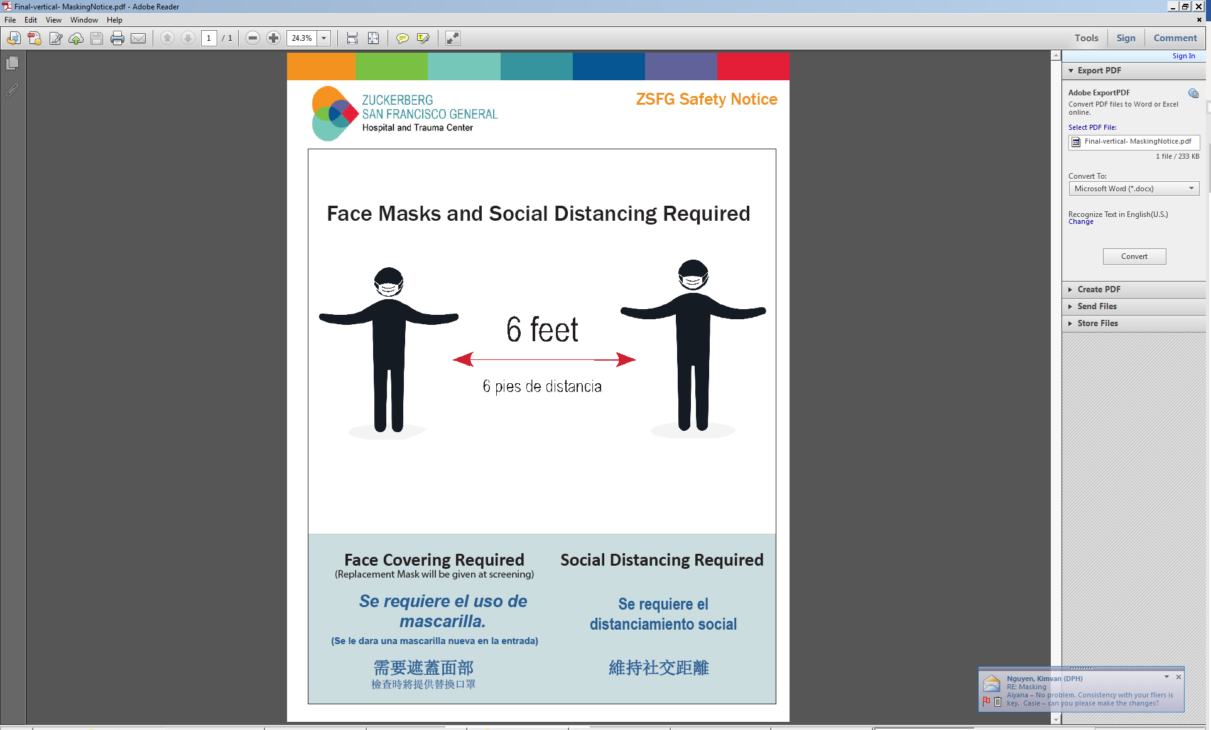Maintain at least six (6) feet of distance from other individuals.
* Wear a personal face covering from home until you are provided with an isolation mask at the entrance. **Face coverings must cover both the nose and mouth at all times when worn.**

Maintain these six (6) feet distances throughout the ZSFG campus, including elevators, lining up for cafeteria meal and as much as possible in the work area. There is a four (4) person maximum in ZSFG elevators.

## 

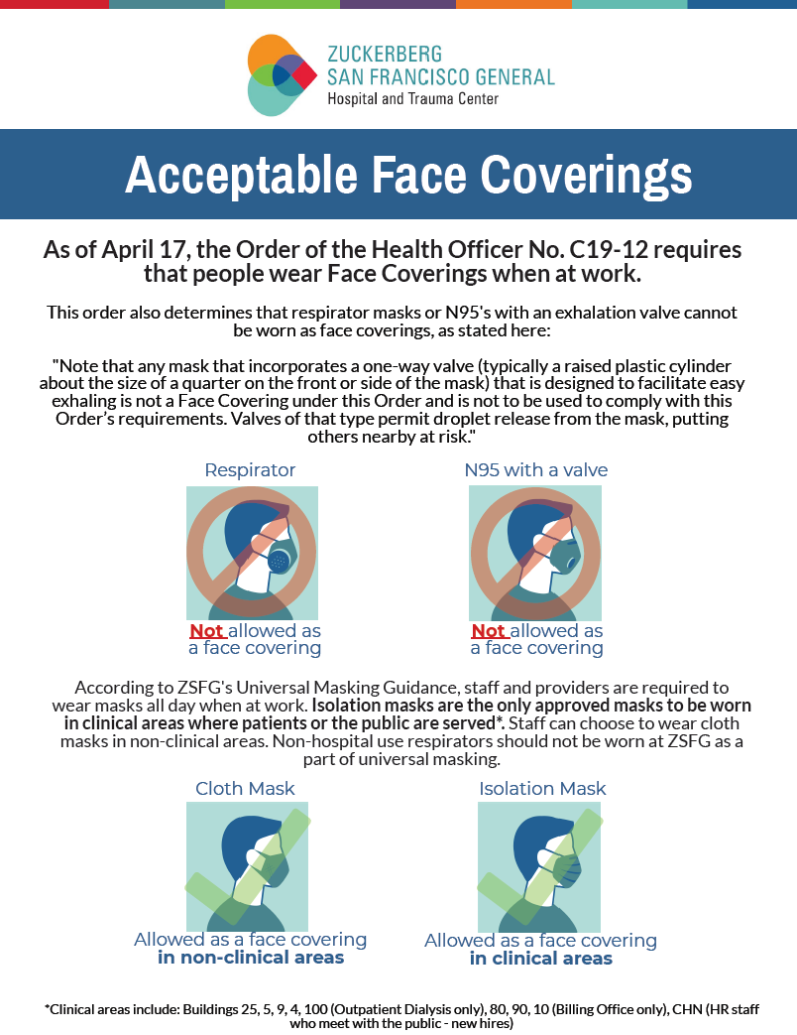



**Attesting to ZSFG Orientation to COVID-19 Updatesnts Attestation**

My Student Signature below attests that I, ________________________________ (print name)

have read the ZSFG COVID-19 Orientation material and agree to adhere to the guidelines outlined. If I do not follow the ZSFG COVID-19 orientation information, I understand that I will be asked to leave the ZSFG campus.

Signature: _______________________________________

Date: ___________________________

Detach this page when signed by student.

Preceptor will keep this signed copy with the student’s other ZSFG onboarding documentation.